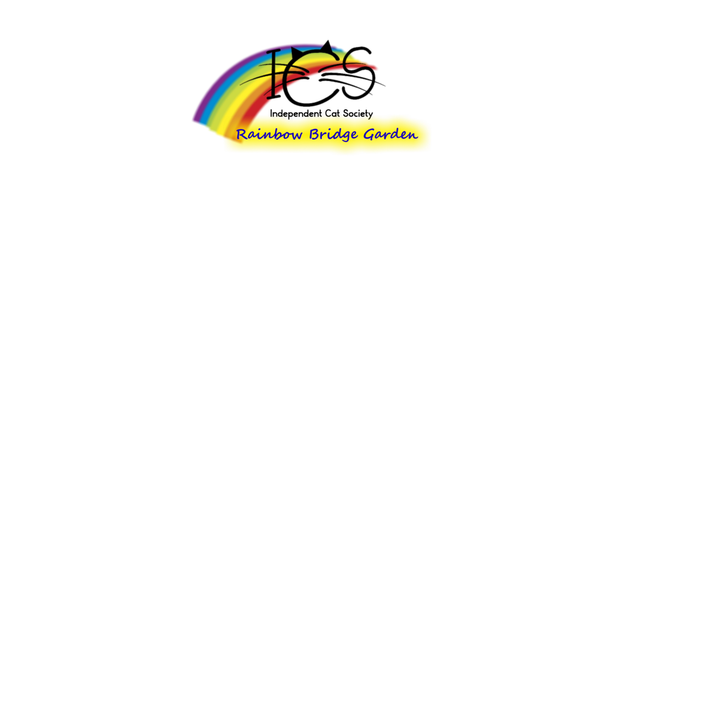

INDEPENDENT CAT SOCIETY RAINBOW BRIDGE GARDEN
ORDERING FORM FOR MEMORIAL BRICKS
Partnering with Purdue North Central, ICS has built a Rainbow Bridge Garden on our tree-filled shelter grounds. This garden is beautiful place where the human animal bond can be celebrated and your special pet of any species remembered. Engraved bricks in two sizes are available.

These can be copied if more forms are needed, and can also be found on our website at www.catsociety.org or on Facebook. Payment can be made by sending in a check or by Paypal. Please make sure to include your contact info so we can double-check spelling with you if necessary. Proceeds from the sale of the bricks will go towards our building funds for much-needed shelter renovations. Bricks are placed every spring, followed by a Memorial in the garden all are welcome to attend.

The form below is for an 8x8 brick. The cost per brick is $125.

15 characters-5 lines- spaces and punctuation counts as a character

__ __ __ __ __ __ __ __ __ __ __ __ __ __ __

__ __ __ __ __ __ __ __ __ __ __ __ __ __ __

__ __ __ __ __ __ __ __ __ __ __ __ __ __ __

__ __ __ __ __ __ __ __ __ __ __ __ __ __ __

__ __ __ __ __ __ __ __ __ __ __ __ __ __ __

The form below is for a 4x8 brick. The cost per brick is $75.

15 characters-3 lines

__ __ __ __ __ __ __ __ __ __ __ __ __ __ __

__ __ __ __ __ __ __ __ __ __ __ __ __ __ __

__ __ __ __ __ __ __ __ __ __ __ __ __ __ __

Please include contact info so we can verify spelling and make sure we turn the order in correctly!

Name_______________________________________________

Address __________________________________________________________________________

Phone#_________________________________

email_________________________________________________________________________

Best way to contact you:______________________________________

Thanks for being a part of the future of ICS!

